The Life and Times of
Donald (NMI) Munro
The “Don”
The Man
The Myth
…and, the Legend lives on…
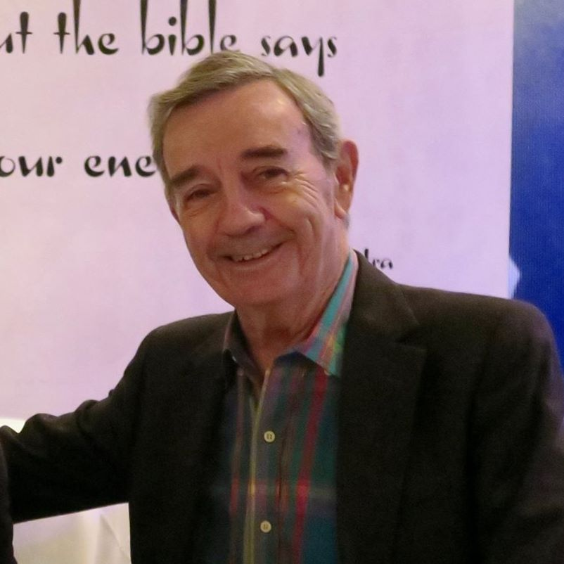

Donald Munro was born July 3, 1937
in Inverness, Inverness-shire, Scotland
Donald Munro passed away August 15, 2020
In Palm Springs, California

Donald Munro - History
(updated November 17, 2022)

- Donald (NMI) Munro was born July 3, 1937 about 11:45 PM in Inverness, Inverness-shire, Scotland
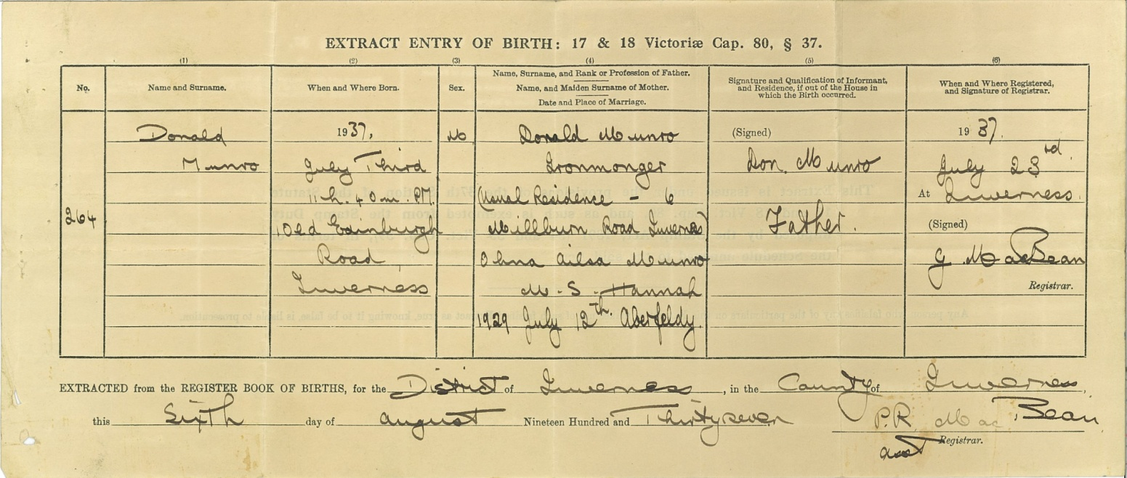

- Parents
Donald (NMI) Munro (13 March 1904 - 31 July 1981; 77 when he died) and Ohna Ailsa Hannah (2 February 1910 - March 1991, 80 when she died)

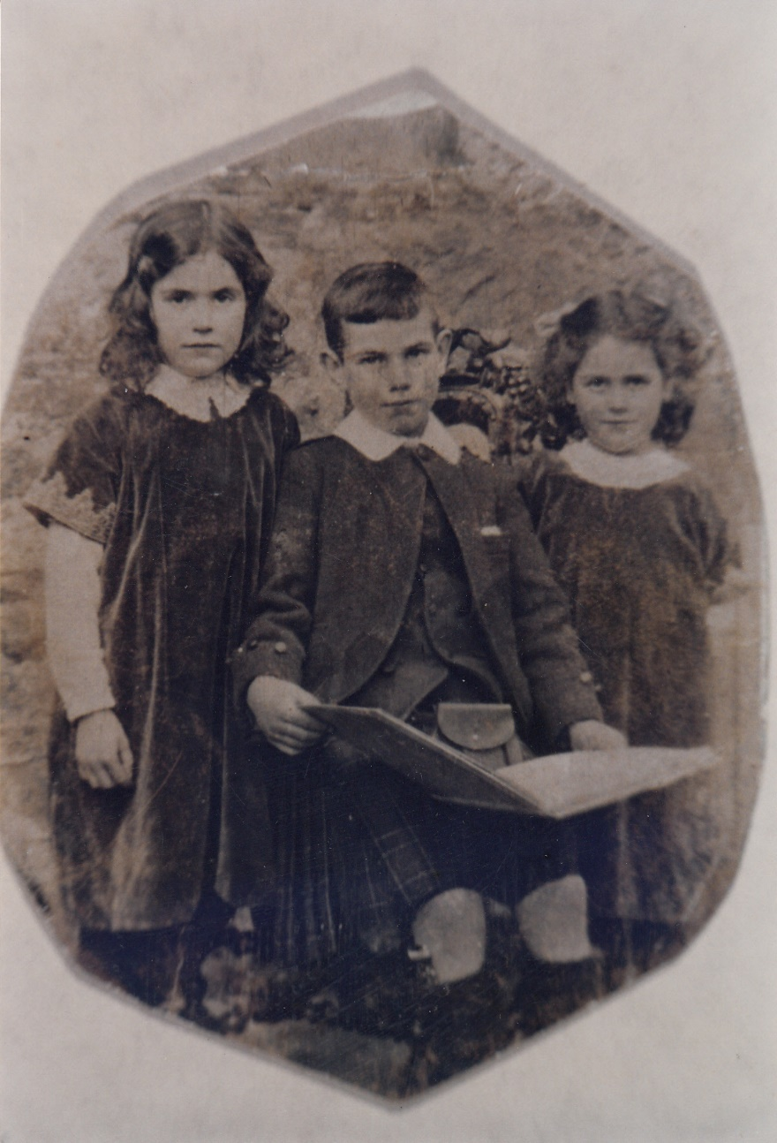
Munro Kids – about 1914
Pat, Donald and Margaret
Don’s father and aunts

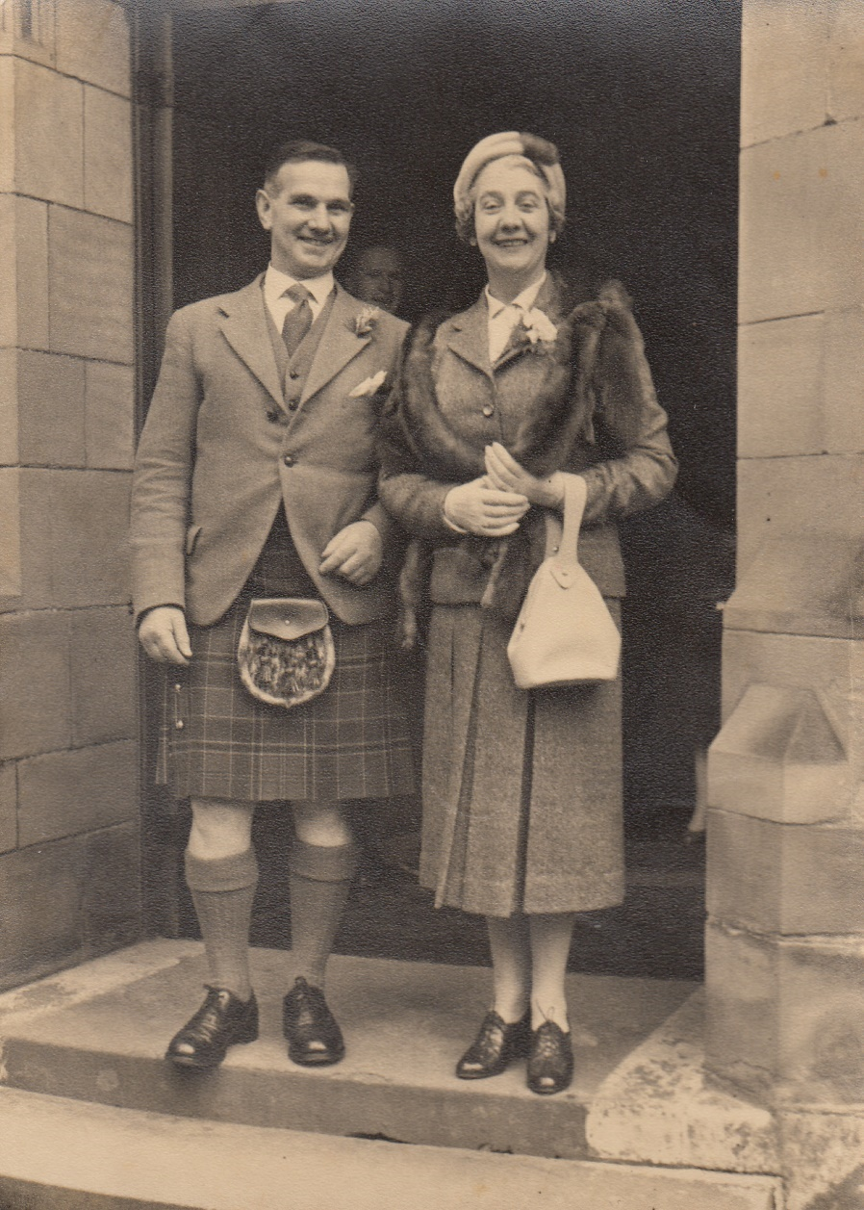
Donald and Ohna Munro
The following notes from Don’s sister, Deirdre.
“It is amazing that you have found these photos. Yes they are our parents, obviously taken at a wedding in Inverness. When? I cannot say it looks very old fashioned, Mum`s shoes etc. and where did she get that handbag!! I should not be critical!! It is a good photo of Dad but it is so unusual for him to wear such a tight jacket, he was always so particular. Anyway, nice to see him looking so happy.”

This is an early photo of the Munro family.
Don’s father is at the far right standing

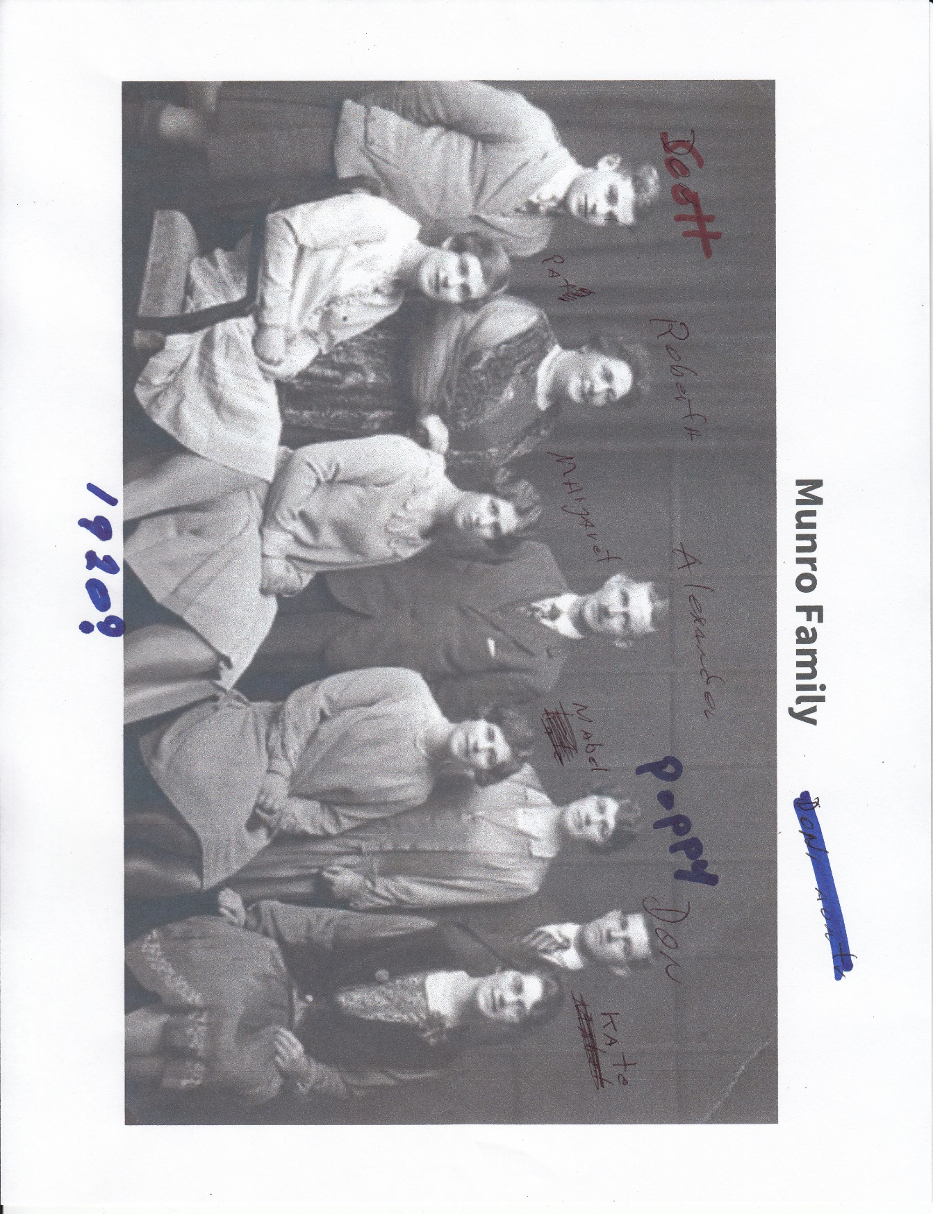

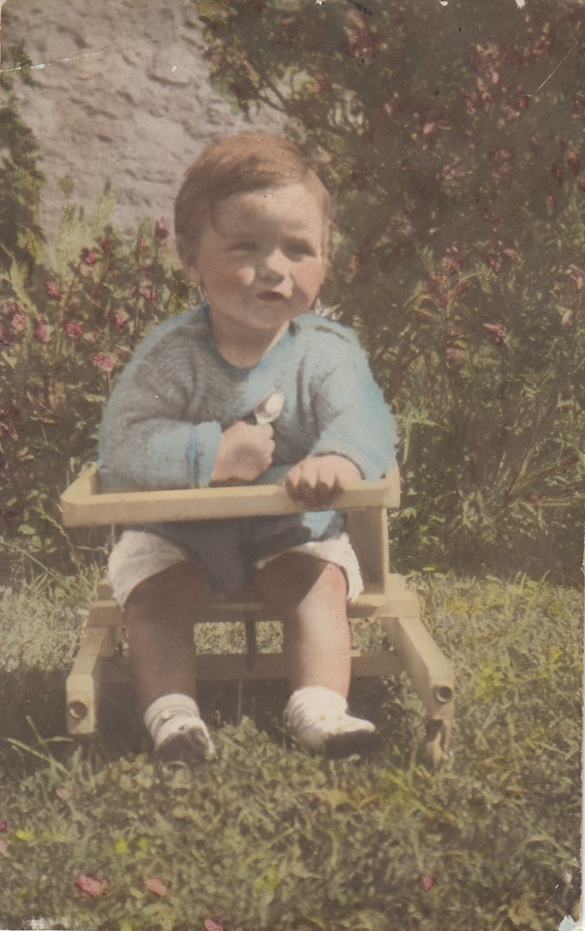

Don in that wee chair must have been taken when we lived at 6 Millburn Road, Inverness.

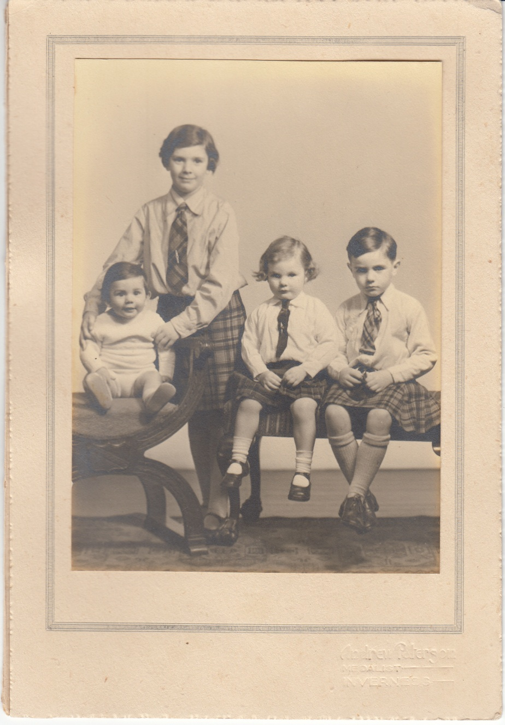
The Munro Kids, Inverness, about 1941:
Ranald, Deirdre, Joan and Donald

From Don’s sister, Deirdre: What a lovely idea, getting an album together. He will love it. The photo was taken in a Studio in Inverness. The “baby” is Ranald, being held by Deirdre then seated are Joan and Don. It must have been done in 1943. I have always disliked this photo! Where on earth did you find it ?? Anyway, we are much jollier than the photo shows!!

- Sister:
Joan Skelly – ex-husband but still very good friends, Ray Skelly. Sons, Andrew “Andy” Skelly and Michael “Mike” Skelly
102 – 1588 Best Street
White Rock, British Columbia V4B 4G1
Canada
604-536-7029

- Sister:
Deirdre Munro and husband Derek Everett now Young
12 Marksmead
Drimpton, Beaminster
Dorset DTR 3RZ
Phone: 011 44 1308 886 7176
Deirdre.young@zen.co.uk
Derek and I have 3 of a family; The eldest is Alan and then Dee and last but not least is Alistair. We have 7 grand children, so we are very lucky.
When Derek and I married his surname was Everett but for business reasons we changed that to Young. That occurred fairly recently. (as of July 2019)

- Brother:
Ranald “Rannie” Munro – wife Helen and son Rod Munro
St. Mary’s Cottage, Perth Road
Dunblane, Perthshire, FK15 0EZ
Scotland, U.K.
011 44 1786 822507
Born 1944 – really 1942
From Deirdre: The information re Rannie is correct apart from his birth date, that is 1942. He would love to have 2 years knocked off his age but I am afraid it can`t be done like that !
Thank you and Slainte (Gaelic) Deirdre

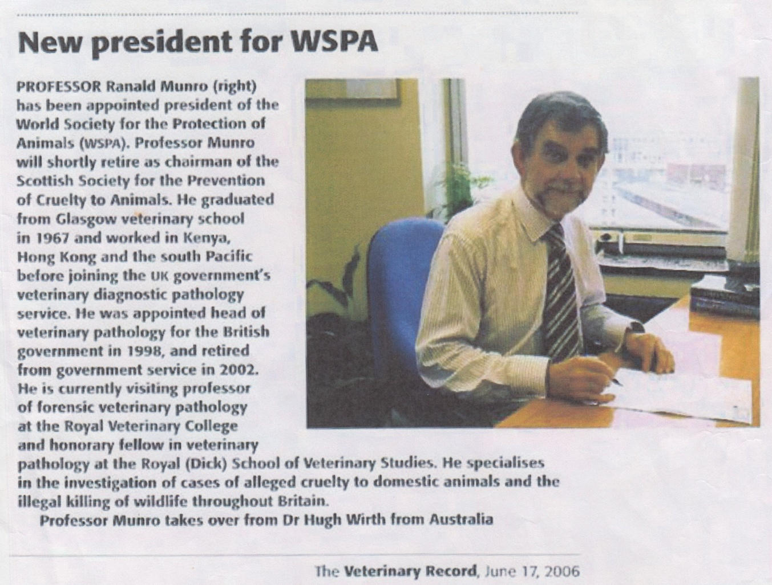

- Don’s now deceased partner Louis Trust/J. Dechambs (sometimes De Chambs) aka “De”
-Born “Louis John Chambs”, March 11, 1922 in Minneapolis, Minnesota, to Louis and an American mother Ellen Champs.
-De passed away at home on Saturday, August 30, 2014 in Kaneohe, Hawaii. Hospice had been assisting De and Don in De’s end time. Don called Hospice and someone came to verify the death. Then about 1:30 AM a very nice and considerate black man from the University of Hawaii picked up the body for research – as were De’s wishes. Remains were later cremated and disposed of. On the death certificate, the name is “Louis De Chambs”; Informant is Stacy Lenze from U.H.; Donald Munro is listed as “Next of Kin”. Lee Labrash from UH also helped.
Willed Body Program
University of Hawaii at Manoa
John A. Burns School of Medicine
Department of Anatomy, Biochemistry & Physiology
651 Ilalo Street, BSB 110
Honolulu, HI 96813
Phone: 808-692-1445 to reach either Stacy or Lee
Fax: 808-692-1951

- De’s brother, Vincent Chambs died in Minnesota -- and wife Marilyn and son???
- Don and De were legally married December 2013 in Hawaii
- De served in the US Army at the end of WW II (1944/45?) also in the Suez War???
- From Don’s sister, Joan Skelly, “While in the service of the US Army, De was a "runner" delivering messages using a motorcycle as transportation.” (unable to verify)

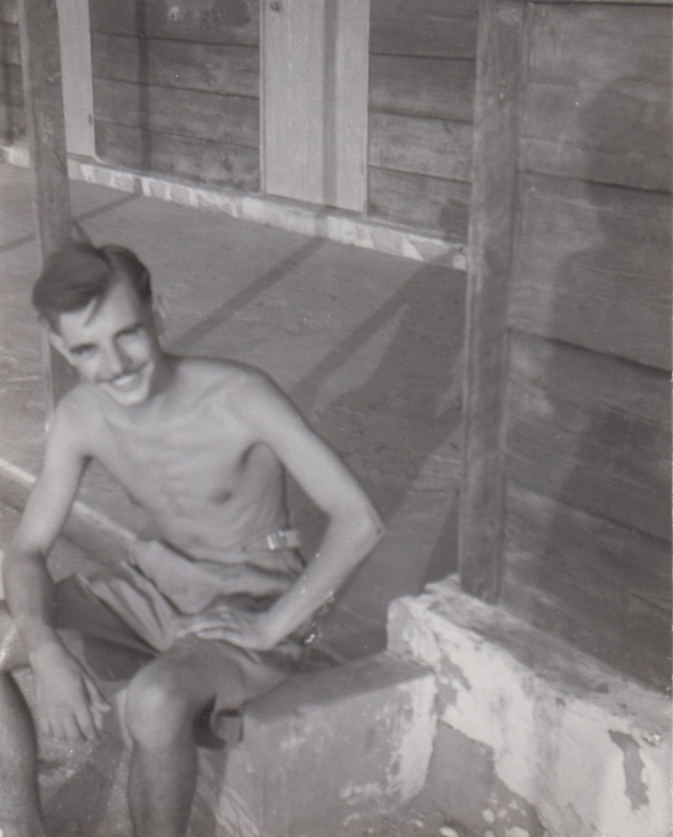
Wonder who this skinny Army kid is???

- Don served in the Queens Own Cameron Highlanders; 1956-1958
With service in Yemen and Egypt
Don’s service number is: 23317917

- (1959-1964)
Don worked for an international insurance company in Nigeria. The company was Liverpool, London and Globe

- (1964-1966)
Don rented a room in a house in Central London for about 1 ½ years.
Worked for Lloyds Broker and walked to his office.

Don and De met in 1965.
Then off to New York City…

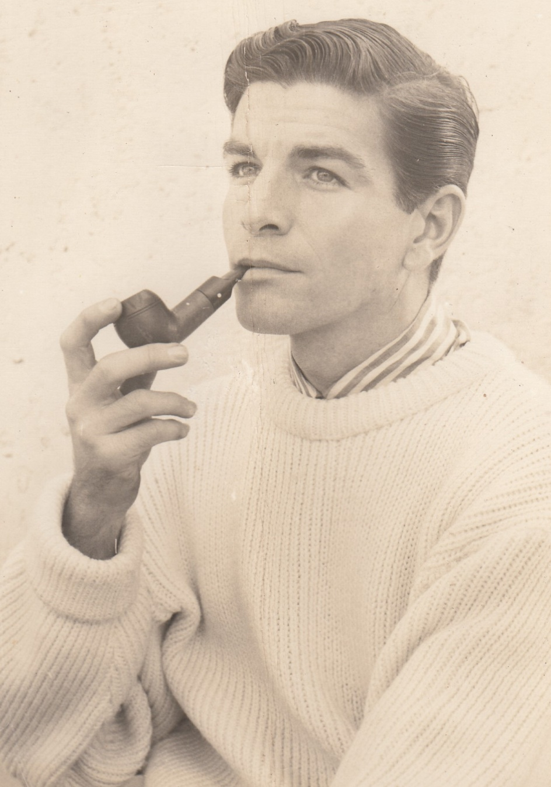
De was very handsome…

- (1966-1967)
July 1, 1966 - Don moved from London to New York and lived with De in his apartment
25 West 10th Street
New York, Manhattan, NY
ALgnan 4-7592

- (196?-1985/86)
Don and De
De and Don lived upstairs with their business downstairs
380 Bleecker Street
New York, New York 10014
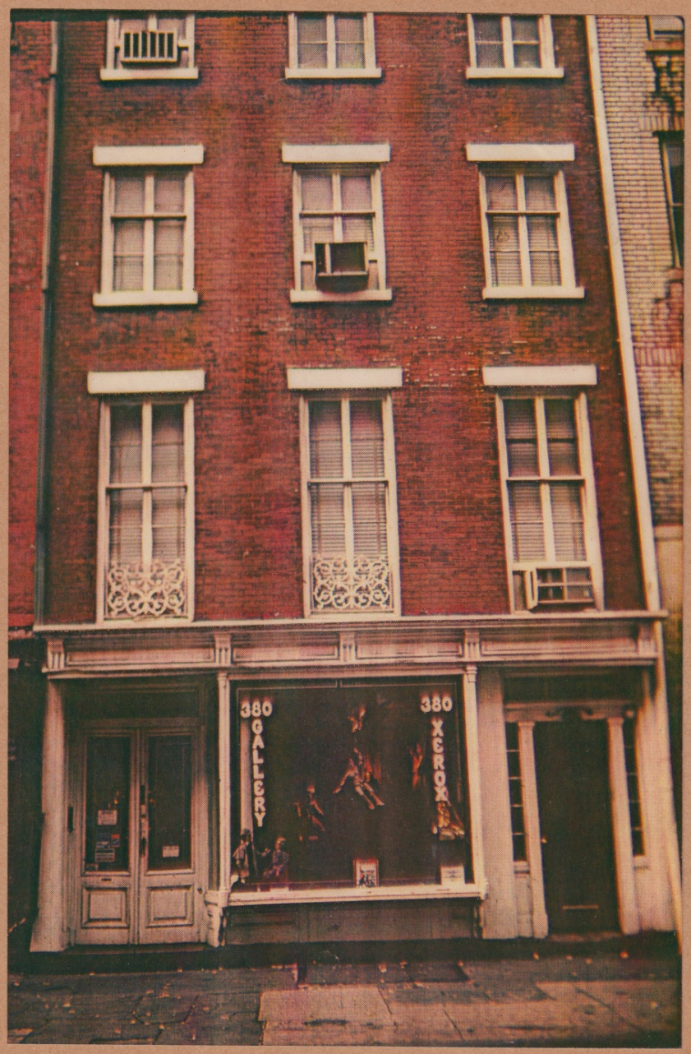
Business entrance on the left. Right entrance to residence on the 2nd and 3rd floors. Design center on the 4th floor, two right windows and the window on the left was the rental.

- Don received his U.S. Citizen in 1975 in New York City, New York, US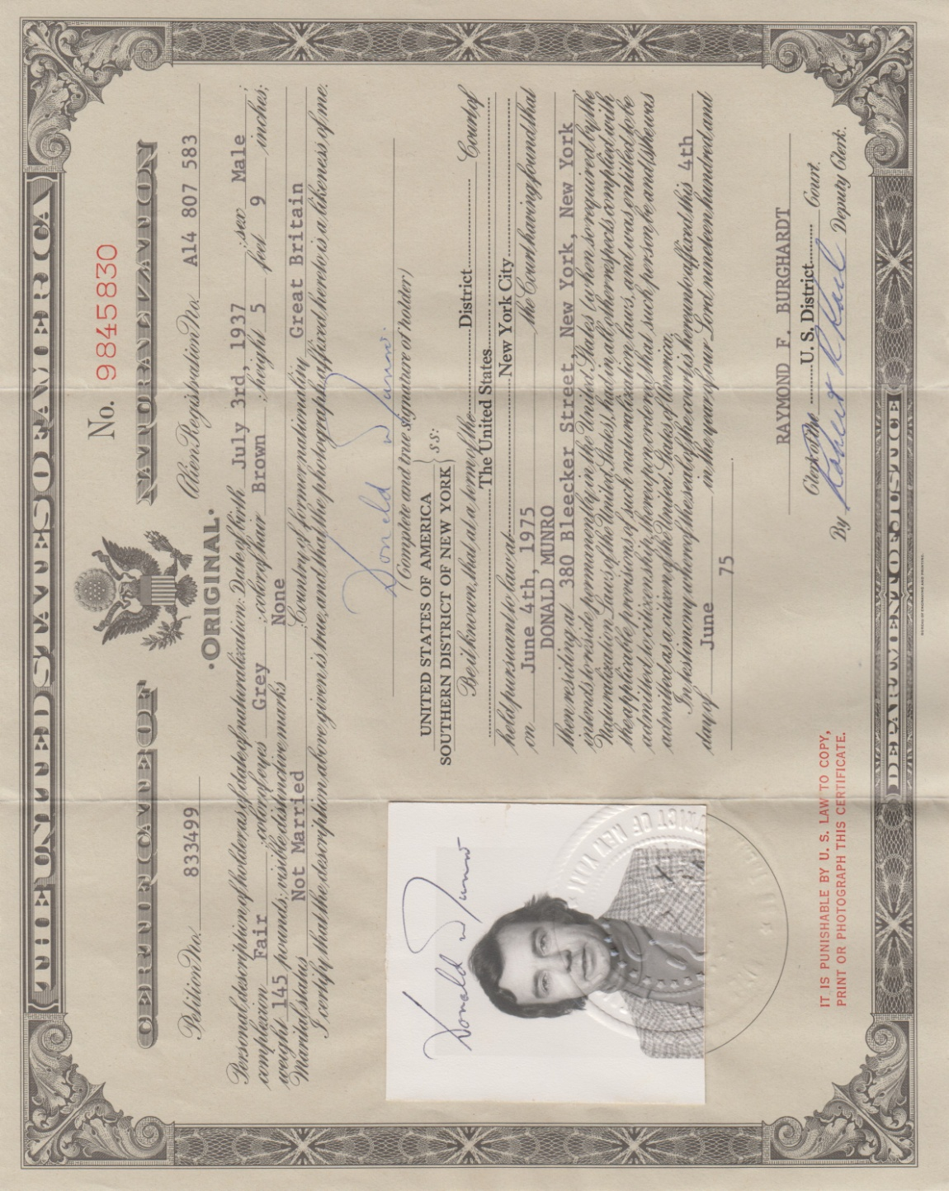
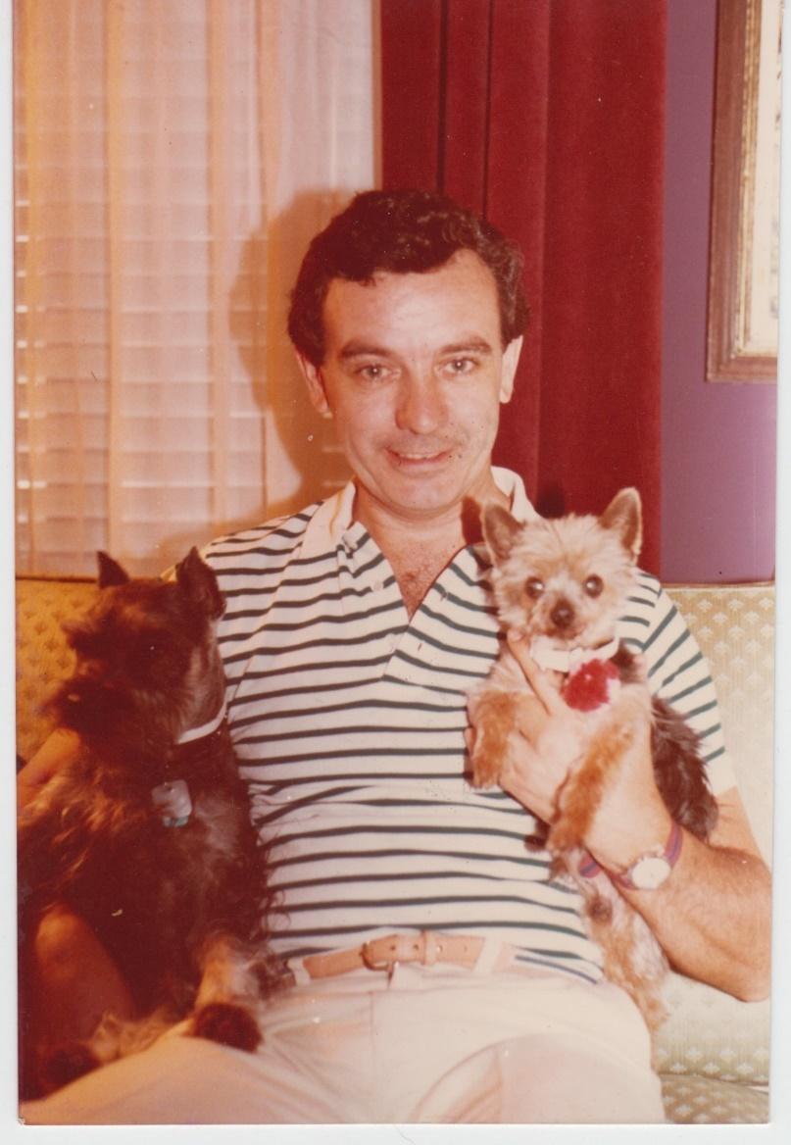
Don at home on Bleecker Street
With good friends
May 1984

- (1986)
Don and De stayed in an apartment for just a couple of months
Honolulu, HI. Possibly an apartment/condo in the Marco Polo.

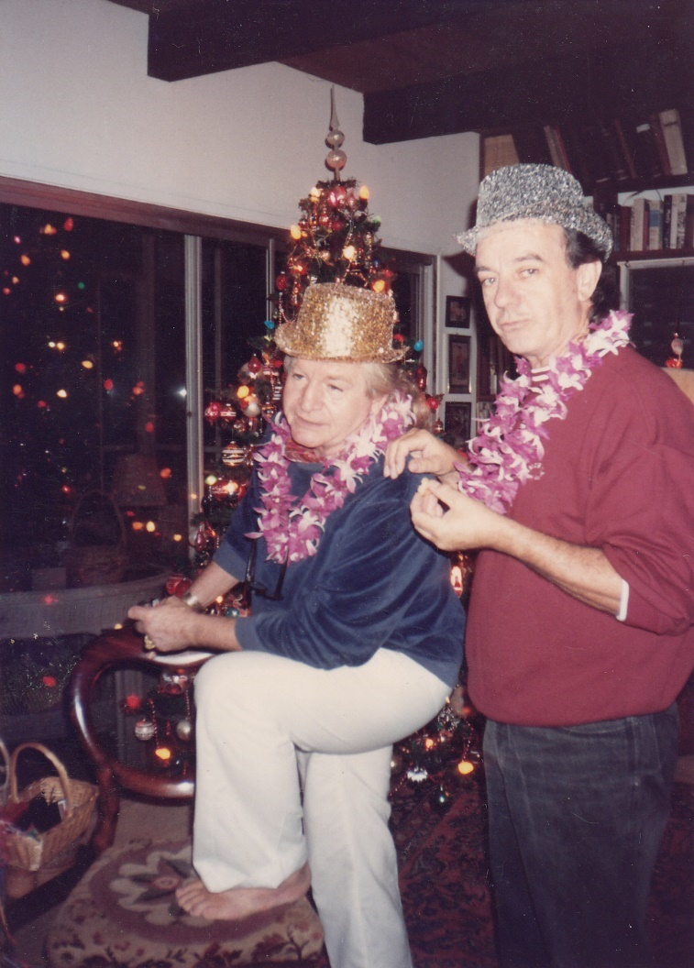
De and Don
Christmas 19??

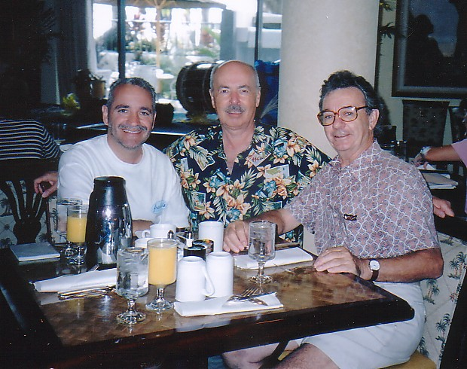
Clark Argeris, Tom Moore and Don
Lunch at the Kuhio Beach Grill in Waikiki
March 26, 2004

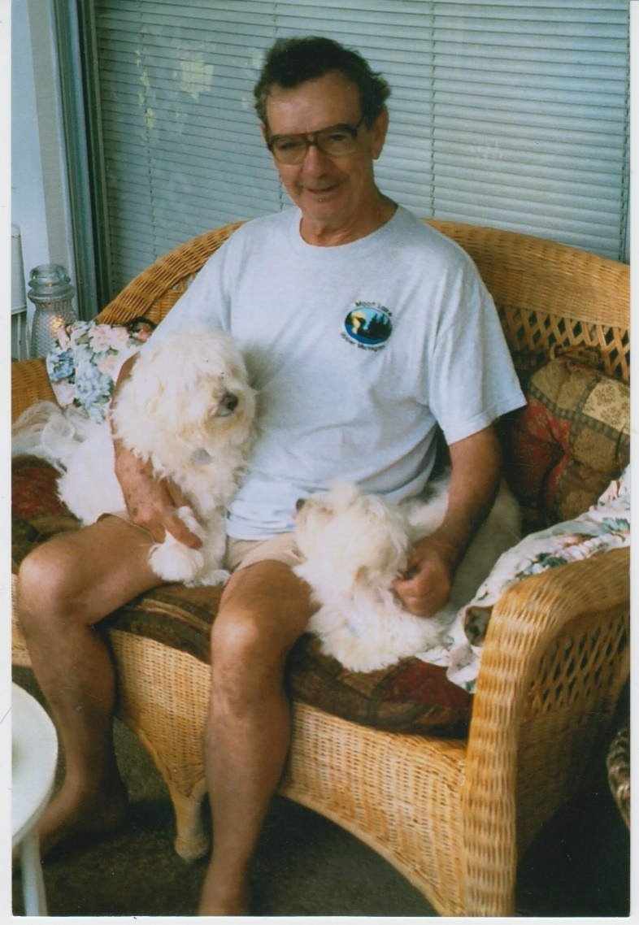
Don at home in Kaneohe
2008

August 14, 2020
Dear Tom,

I have attached an additional picture taken on the same date, with Don and De. They had invited us both to their home for a celebration on my birthday. De was charming and accomplished, and he and Don were warm and considerate hosts. De had a photograph album of his past, which included trips to China and Taiwan in the 1950s as honored guests, feted and celebrated at banquets. Don loved De deeply and was always fussing around him, and De and I shared a fondness for Scotch. Their house was full of beautiful objects, collected over a lifetime of travel. Their B&B guest bathroom was crammed with interesting doo-dads, and I remember thinking: how long does this take to clean? The house entryway featured De's paintings of male nudes, which was always a welcome attitude-adjusting moment! We visited several times over the years.

I recall our memorable lunch with Don and De one sparking Saturday at the "House without a Key" restaurant at the tony Halekulani, I believe it was De's birthday and we had invited them. It was the last time we celebrated with them in Waikiki. De and Don were engaging and entertaining conversationalists, and time passed quickly and enjoyably, with stories, smiles, laughs, and loving aloha.

Don occasionally complained that De overspent on beautiful things, and I hadn't quite realized the math he was dealing with until Don and I took a long walk around Magic Island on a visit after De had passed, and he discussed his practical alternatives. Much as he loved Hawaii, it was clear that he had to move. He mentioned good friends in Palm Springs, and his move there was easy to understand. We visited him in Palm Springs a few times and took him out to lunch, it was clear that he was declining... but, stoic as a Scot! We became quite attached to him, his love for life and his warmth and loving personality and dry humor.

Thank you for compiling such a marvelous record of his life!

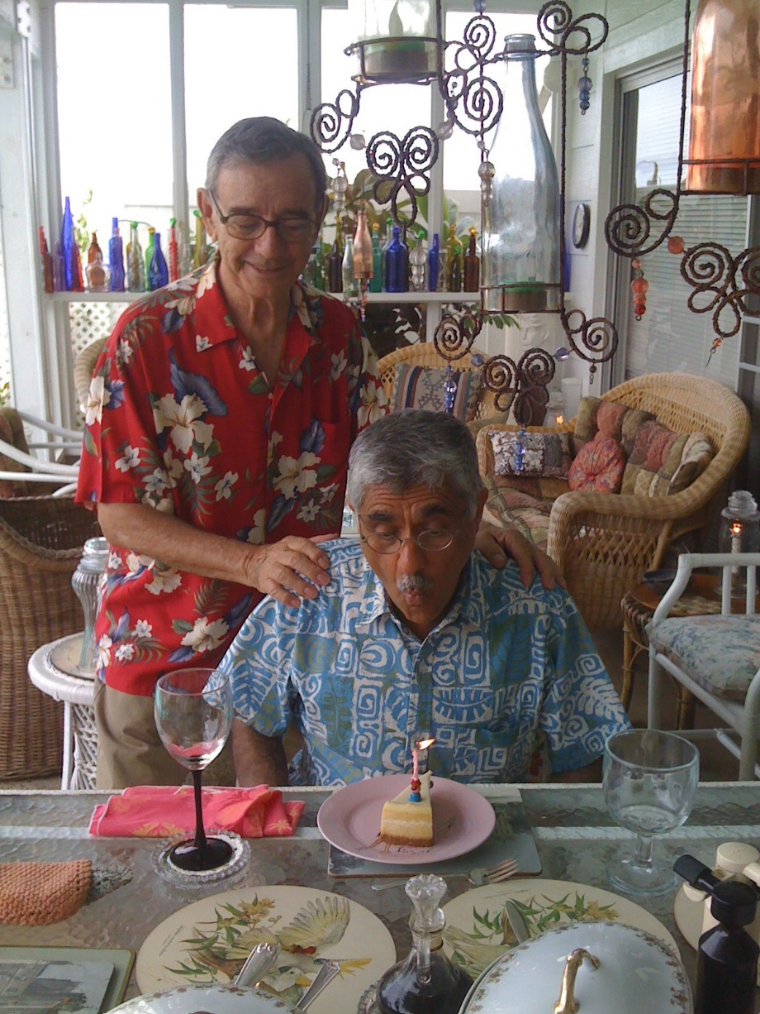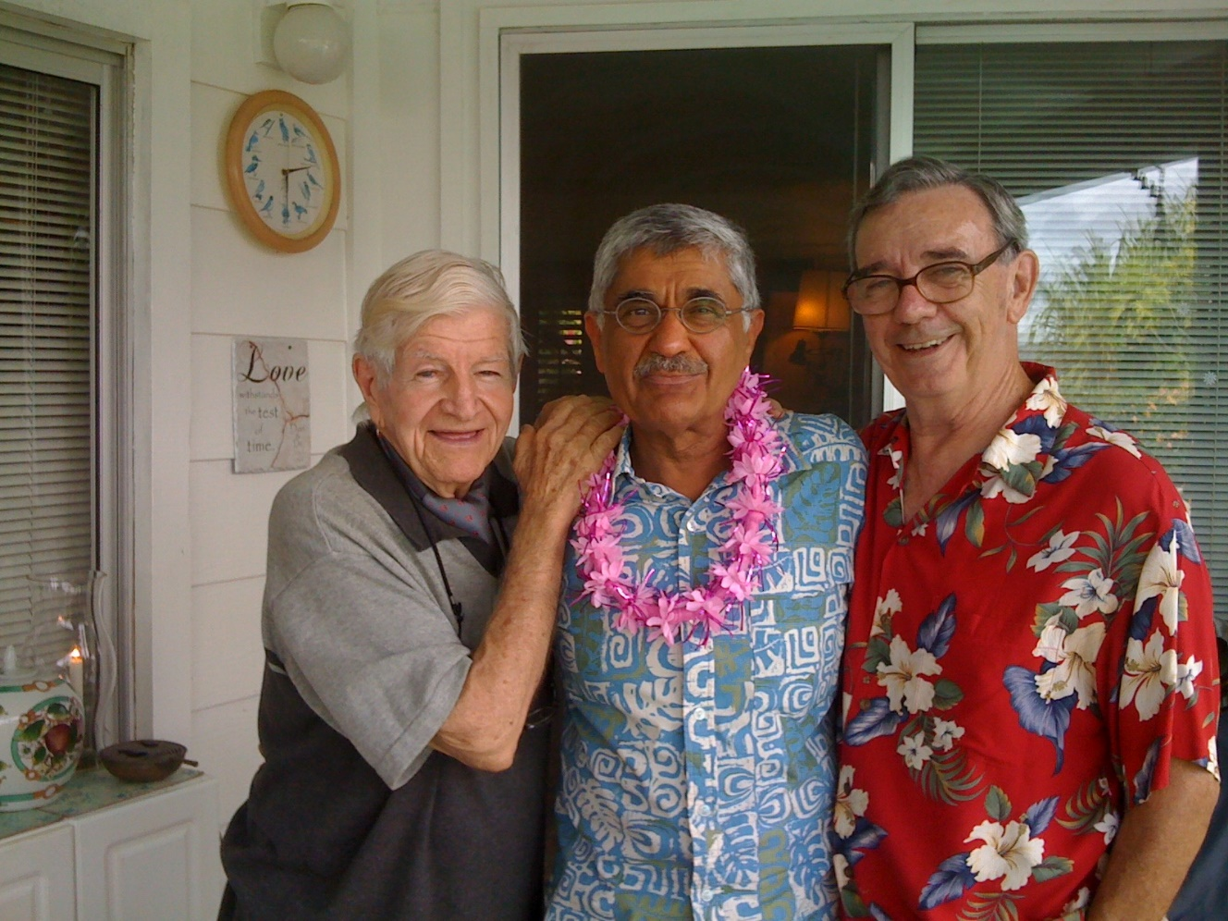

De, Faruq Amad and Don
September 28, 2011

- (1986-2016)
Don and De
46-251 Ikiiki Street
Kaneohe, HI 96744
808-235-1124
1-800-235-1154
FAX 808-236-4877
E-Mail: donm@lava.net
Web Site: www.realmunro.com
De’s Cell: 808-391-6615
(On June 13, 2018, Don told me they paid about $40K for this house, house sold for $785K October 19, 2015; value today 2018 – just over $1m)
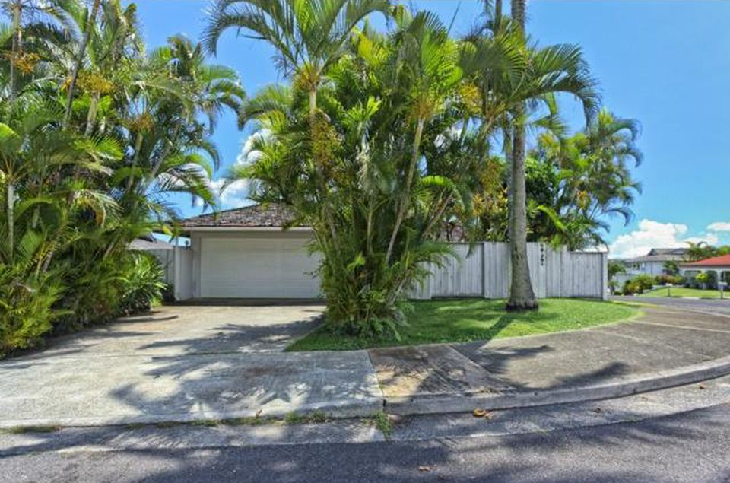

- Don and De were legally married in Hawaii on December 20, 2013.

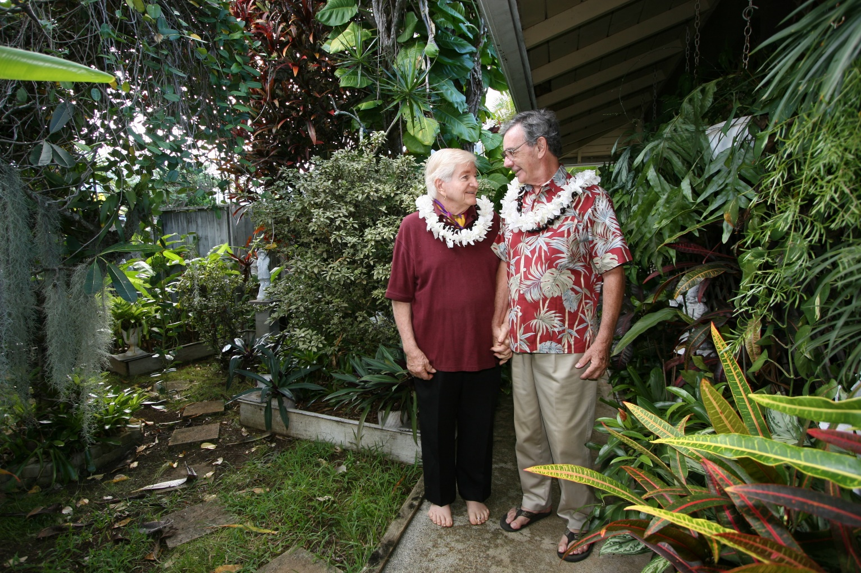

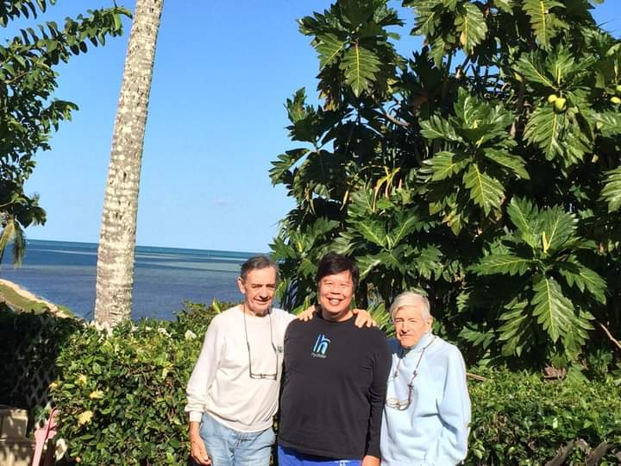
Having a great brunch with inn keepers Donald Munro (Matt Yee: www.mattyee.com ) and his husband De at their Kaneohe b&b. Such a lovely quiet place to stay that only a few lucky guests get to experience!
January 6, 2014

- De passed away at home, August 30, 2014.

- After deciding to move to Palm Springs, Don Stayed with Doran and Kali Porter about 1 month in 2016.

- (2016 - November 18, 2018)
Desert Flower Apartments
2500 E. Palm Canyon Drive, #23
Palm Springs, CA 92262
760-424-5888

While at the above address, Don’s sister, Joan Skelly, came to visit from Canada.
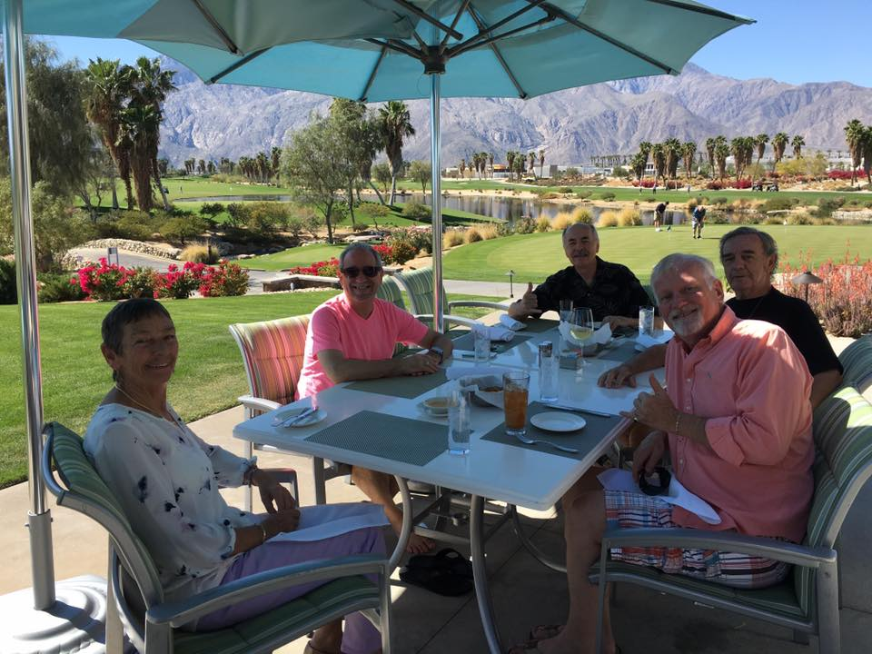
Joan Skelly, Clark Argeris, Tom Moore, Don and Doran James Porter (DJ)
Escena for lunch

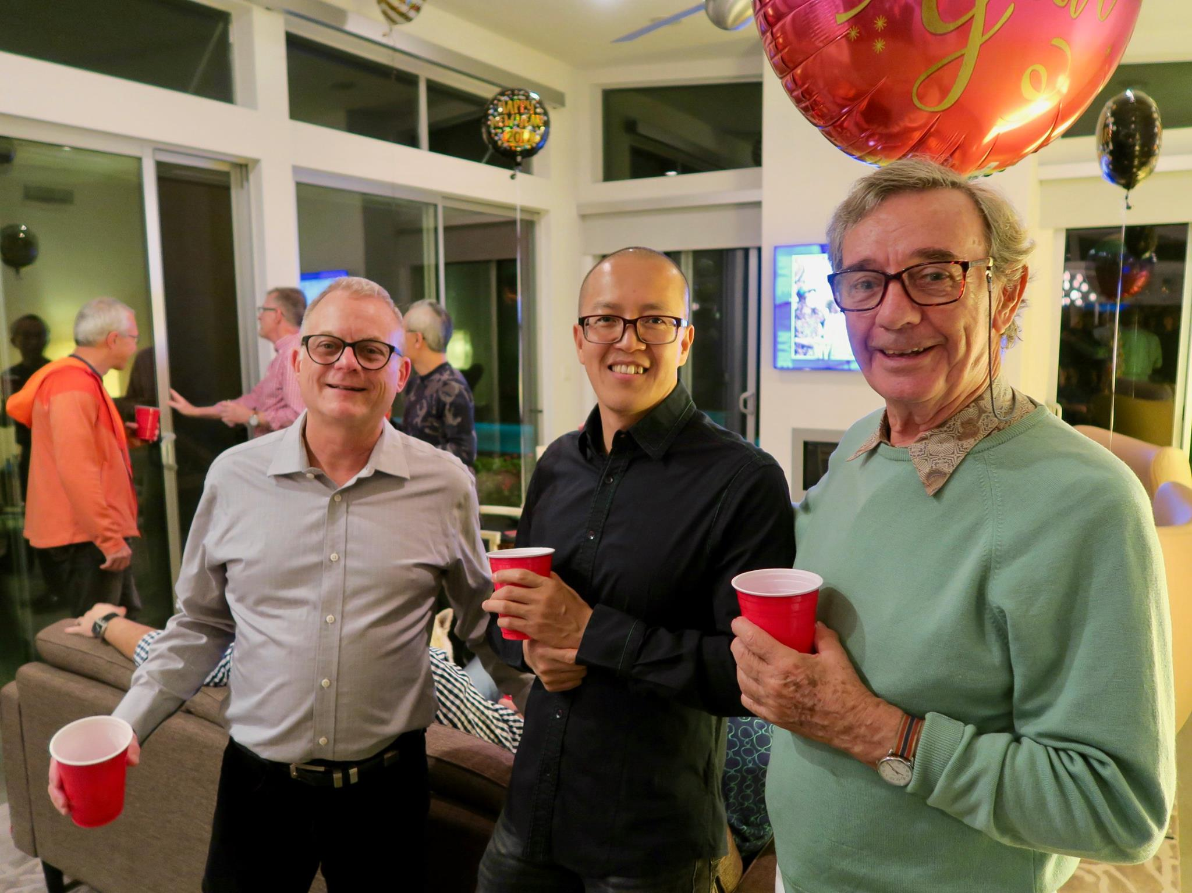
Prof. Fei Wang of Vancouver, Canada, meets Don while attending a New Year’s Eve party celebrating the start of 2017 along with his partner, Howard Goldberg. After hearing Don’s stories at the party, Fei always asks in the years that follow about how Don is doing. (Photo by Lawrence Lim)

- (Don’s address from November 19, 2018 to June 20, 2019)
180 Logenita
Palm Springs, CA 92264
760-424-5888
DonMunro1937@gmail.com

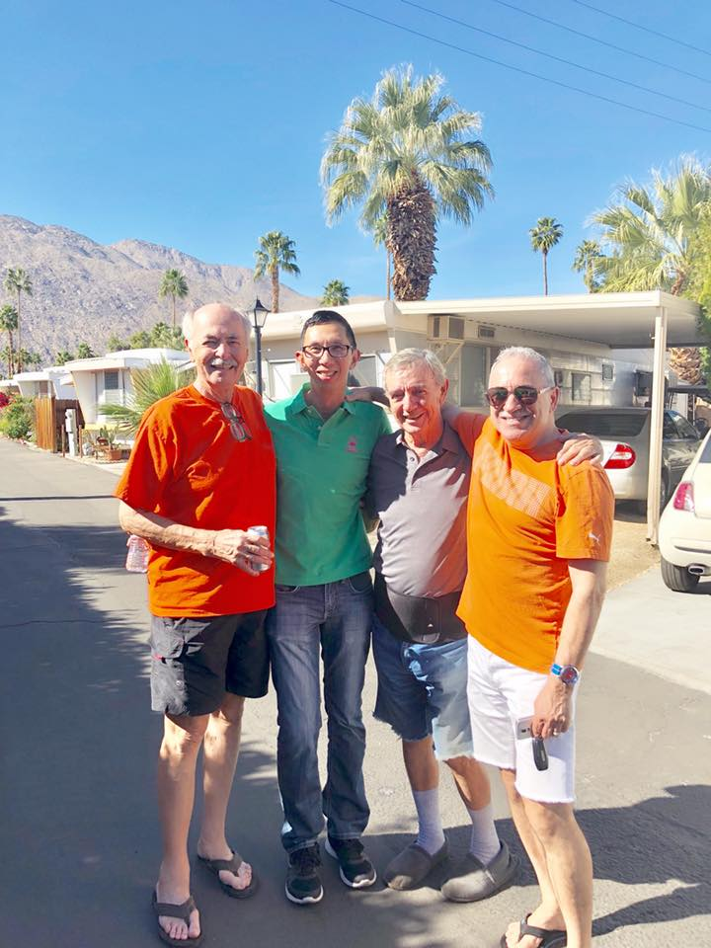
Tom Moore, Lawrence Lim, Don and Clark Argeris
February 3, 2018

- (Don’s Current address)
June 2019 to present
Donald Munro
Windsor Court
201 S. Sunrise Way, Room 129A
Palm Springs, CA 92264
760-424-5888

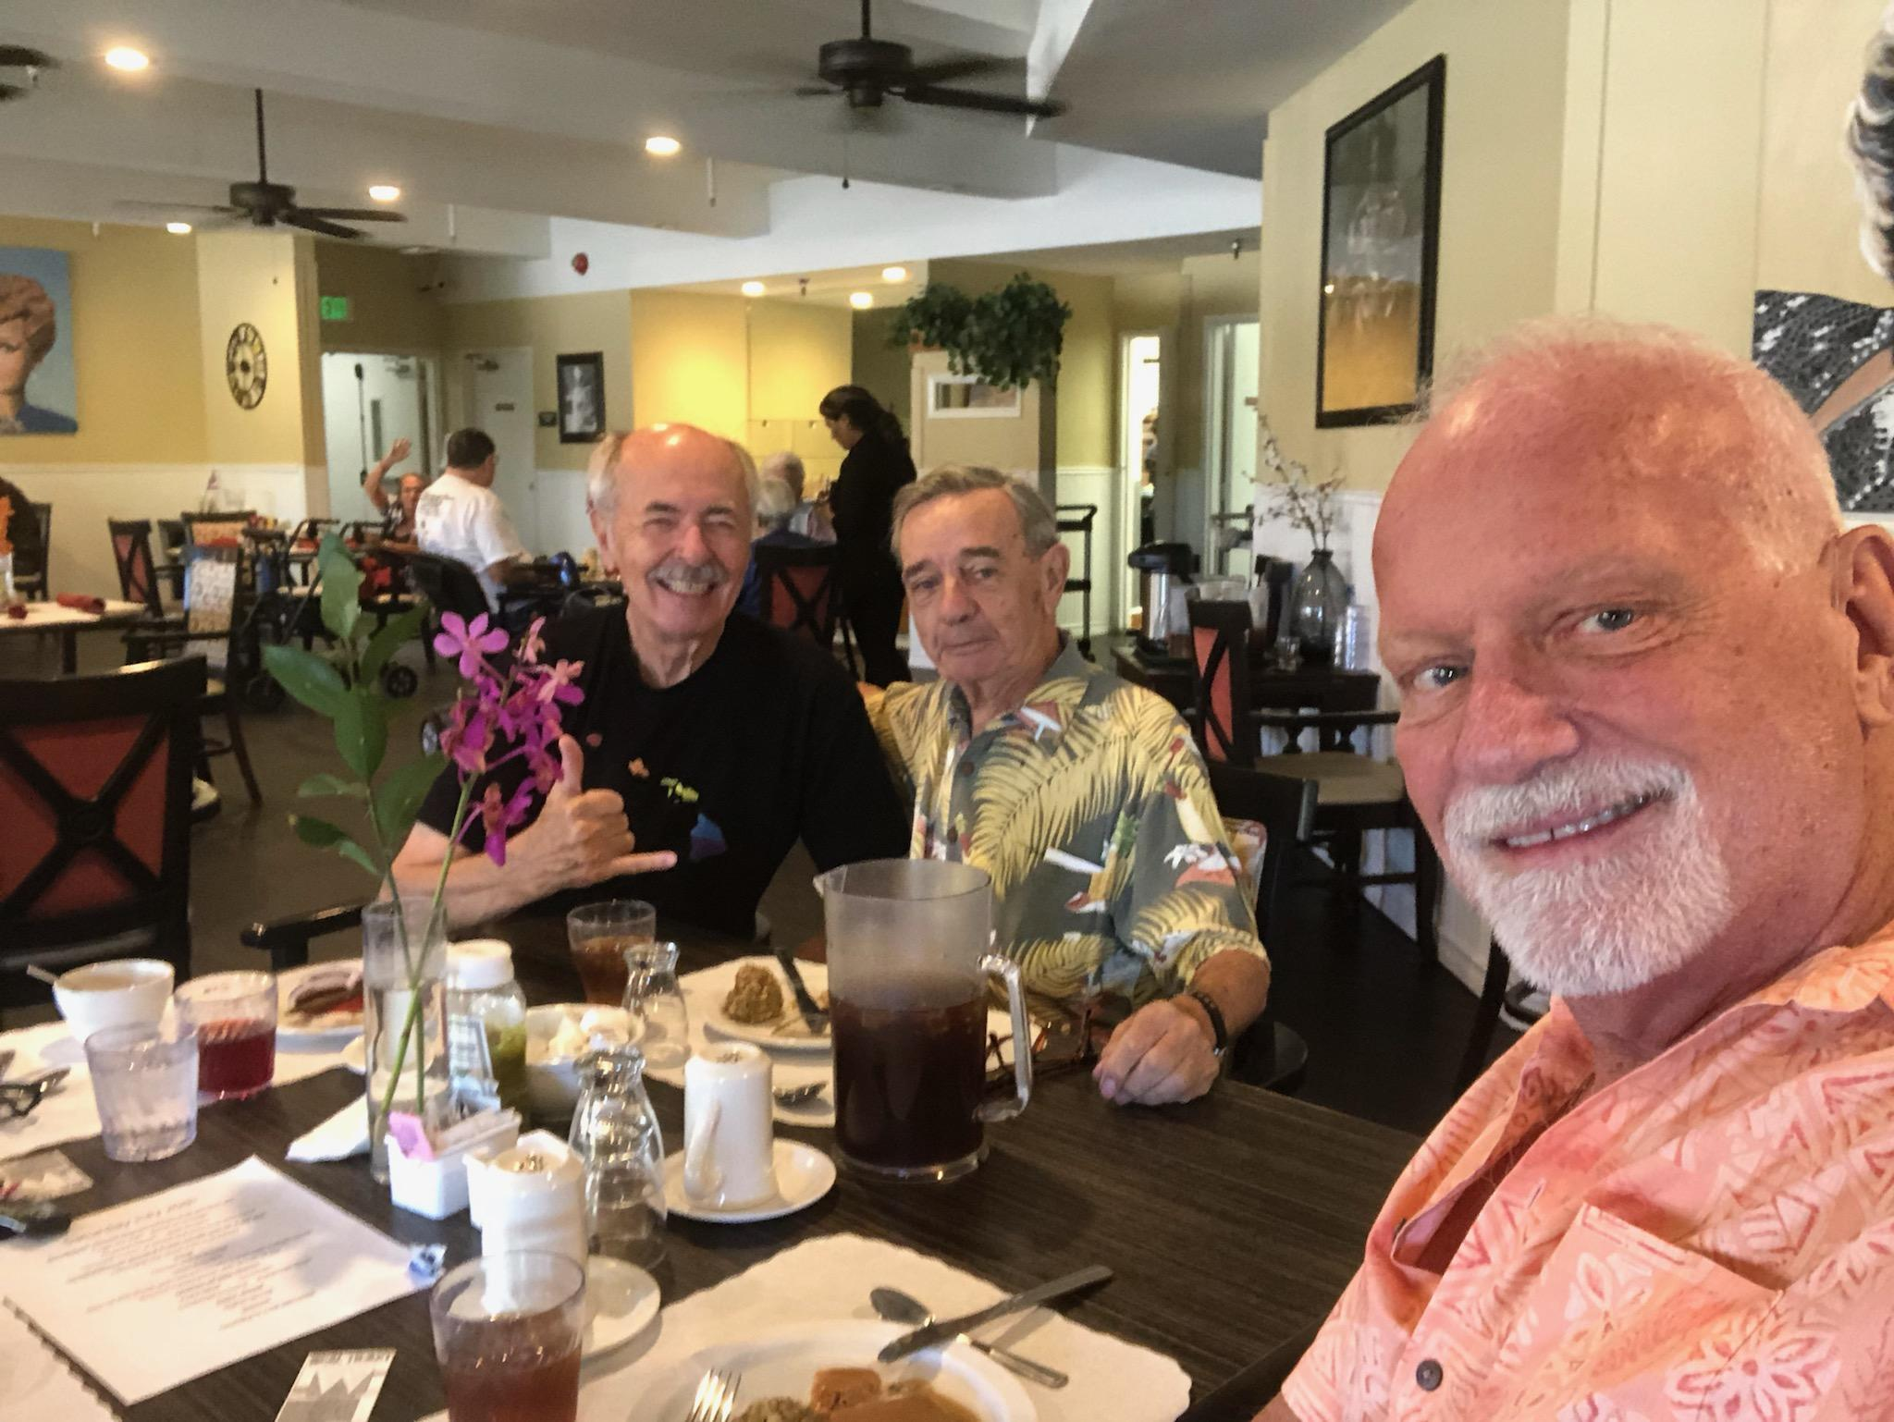
Tom Moore, Don and DJ -- aka Doran James Porter

And the next picture was taken in July 2019 for Don’s 82nd birthday.
It was a grand time for all of us…

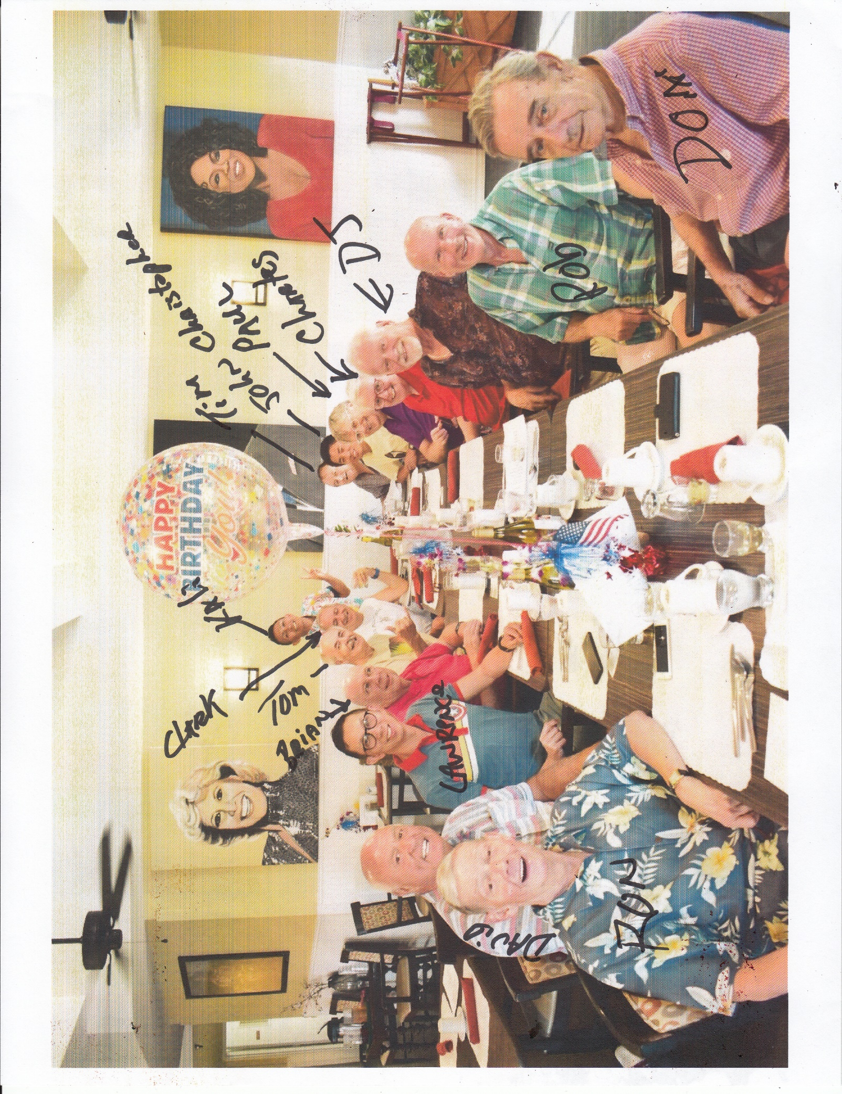
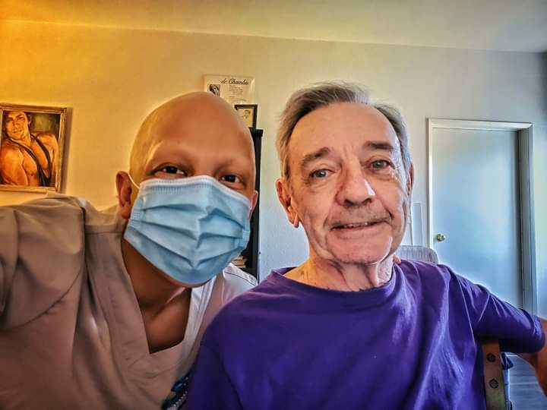
Patrick and Don
Windsor Court
June 2, 2020

